**PRACTICAL 1**

**Name:** Smit M Khobragade

**Sec:** A

**Roll no.:** 64

**Aim:**

1. Create a class Stack and implement the functionalities of the Stack Class
2. Write a program to demonstrate method overloading.  
   Create a class 3DShape and overload a method named volume() to calculate volume of different geometric shapes like sphere, cube, cuboid and cylinder. Create a main() to implement all the methods.

**Code & Output:**

CODE A:

Stack.java

public class stack {

  int l;

  int a[];

  int top=-1;

  stack(int *l*){

    this.l = l;

    this.a = new int[l];

  }

  int isEmpty(){

    if(top==-1){

      return 1;

    }

    return 0;

  }

  int isFull(){

    if(top >= (this.l-1)){

      return 1;

    }

    return 0;

  }

  void push(int *x*){

    if(isFull() == 0){

      this.a[top+1] = x;

      top++;

    }

    else

      System.out.println("STACK OVERFLOW ");

  }

  void peek(){

    if(isEmpty() == 0){

      System.out.println("AT TOP : "+ this.a[top]);

    }

    else

      System.out.println("STACK UNDERFLOW ");

  }

  int pop(){

    if(isEmpty() == 0){

    System.out.println("POPPED : "+ this.a[top]);

    int del = this.a[top];

    top--;

    return del;

  }

  else

    System.out.println("STACK UNDERFLOW");

    return 0;

}

}

Main.java

public class main {

  public static void main(String[] *args*) {

    stack s1 = new stack(10);

    s1.push(4);

    s1.peek();

    s1.push(5);

    s1.push(2);

    s1.peek();

    s1.pop();

    s1.peek();

    s1.pop();

    s1.pop();

    s1.pop();

  }

}

OutputA:

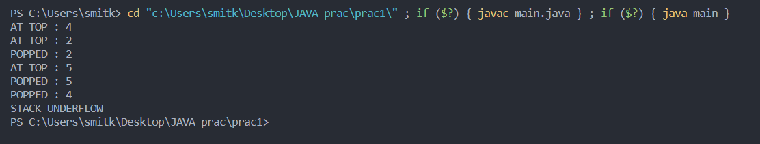

CODE B:

Shape3D.java

public class shape3D {

  //Sphere

  double volume(double *rad*){

    double vol;

    vol = Math.PI * (4/3) * rad * rad * rad;

    System.out.println("VOL OF SPHERE : "+vol);

    return vol;

  }

  // Cube

  int volume(int *side*){

    int vol = side * side * side;

    System.out.println("VOL OF CUBE : "+ vol);

    return vol;

  }

  double volume(double *l*,double *b*,double *h*){

    double vol = l*b*h;

    System.out.println("VOL OF CUBOID : "+ vol);

    return vol;

  }

  double volume(double *h*, double *r*){

    double vol = Math.PI * r * r * h;

    System.out.println("VOL OF CYLINDER : "+ vol);

    return vol;

  }

}

Main.java

// package prac1b;

public class main {

  public static void main(String[] *args*) {

    shape3D s1 = new shape3D();

    s1.volume(4.3, 1);

    s1.volume(1.0, 0.1, 10);

    s1.volume(2.4);

    s1.volume(10);

  }

}

OUTPUT B:

